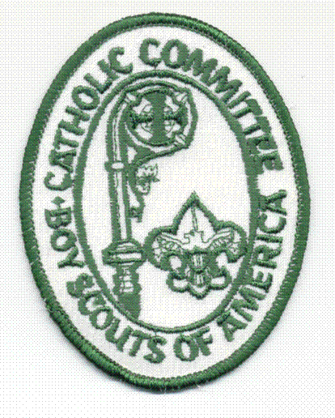
Nomination For

The Bronze Pelican Emblem
The Bronze Pelican Emblem is a diocesan recognition defined by the Catholic Committee on Scouting.
It may be presented to any adult working in the scouting program under Catholic auspices, to Catholics in units not partnered by the Church and to those who have made a significant contribution to Scouting in the field of Catholic relationship. It may be given to Catholic men and women, including priests and religious.
The Purpose of this emblem is to recognize outstanding contribution to the spiritual development of Catholic youth in Scouting, BSA, with emphasis on developing Christian ideals and awareness of God in all Scouting activities.

Candidate Name ____________________________ Age __________ Unit No. ____________

Street ____________________________ City ____________ State _____ Zip ___________

Parish___________________________ Sponsoring Institution__________________________
Parish Approval
It is suggested that the recipient’s parish, sponsoring institution, or unit pay for the emblem.
Call our office or visit our website for current pricing.
The above named candidate is acknowledged worthy of receiving this emblem.
Pastor Name__________________________ Date_______________
Signature___________________________________
Brief comments: ______________________________________________________________
___________________________________________________________________________
___________________________________________________________________________
Important Information
Applications are accepted throughout the year. Nomination applications are reviewed annually in early January. Nominations received by the First Friday of December will be reviewed, and notification of approval or deferment will be given to the Scouter listed below in early-to-mid January.
Submitted by Position in Scouting
___________________________________ __________________________________
Address City State Zip
___________________________________ __________________________________
Phone Email
__________________________________________ _________________________________________
Emblem to be paid by Office Use only
__________________________________________ Mail to address above____ Pick up ____ Date______
*See above note under “Parish Approval” Date of Presentation of Emblem________________
Catholic Committee Approval
The Committee reviewed the nominee’s record and certifies that he/she meets the standards of the Bronze Pelican.
Signed: ____________________________________________ Date: __________________
Chairman, Adult Award Committee
Signed: ____________________________________________ Date: __________________
Chairman, Catholic Committee
Signed: _____________________________________________________ Date: ______________________
Chaplain, Catholic Committee rev. 1/10/14
Bronze Pelican Requirements
Provide complete and accurate information. Include dates or years of participation in specific activities, offices, training completed and other awards received. It is extremely helpful to have reference letters from people who can substantiate the character of the Nominee. (Use additional sheet for details)

1. Registered volunteer Scouter
2. At least 21 years of age.
3. A minimum of three years adult service to Catholic youth in Scouting.
4. Active member of the Church.
5. Record of developing character and awareness of God in Scouts, so that they may become better members of the
Church.

Record of Nominee
6. Describe what this person has done to promote and enhance the spiritual development of Catholic youth in Scouting.
7. Describe leadership in Cub Scouts, Boy Scouts, Venturing and other youth programs.
8. Describe the candidate’s religious role or activity at the parish, diocesan level or other.
9. Describe promotional activities for Religious Emblems with Cub Scouts, Boy Scouts, and Venturers.
10. Describe leadership in promoting a visible (uniformed) Scouting presence in the parish.

Guide for Selection Committee
Below are some examples, a combination of which might make a leader a possible candidate for this recognition.
These suggestions are offered as a guide only; however, they are indicative of some of the things that the Award
Committee will be looking for. This list is not inclusive. There are many other areas that can be considered.

A. Promote the religious emblem program for Catholic youth. | H. Be responsible for Catholic youth being transported to Mass while on camping trips or summer camps.
B. Participate activity in the Catholic Committee programs: Adult or Youth Retreat, Cub Scout Day of Recollection, S-F Catholic week Camp, Scouter Development: (Ministry Formation for Leaders) or being instrumental in having others attend. | I. Encourage the true spirit of ecumenism as well as parochial responsibility and Catholic leadership within various Scout units under Catholic auspices.
C. Serve to promote units to perform Catholic activities and service projects for the church. | J. Be instrumental in promoting the full Scout program, “Scouting is Youth Ministry” in all parishes or Catholic organizations.
D. Attend Religious Emblem Training, become trainer, or serve as a counselor to the youth. | K. Make a significant contribution to Scouting in the field of Catholic relationships.
E. Promote and participate in Scout Sunday observances. | L. Be instrumental in organizing new Scouting groups under a Catholic charter or leadership.
F. Serve to bring Scouting to more youth under a Catholic identity. | M. Assist parishes and Catholic organizations in recruiting leaders for scouting programs.
G. Promote Vocations thru Scouting | O. Become a member of the Catholic Committee on Scouting.

